Test of Sparta 6DOF Convolver plugins – Measure of latency and cross-fading
Binelli’s version:
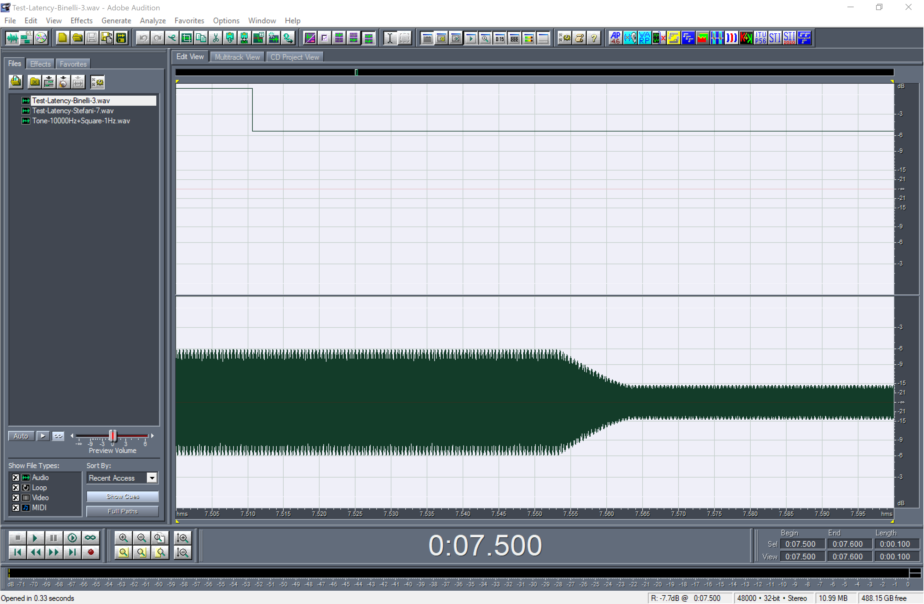

Stefani’s version (with MCFX engine)
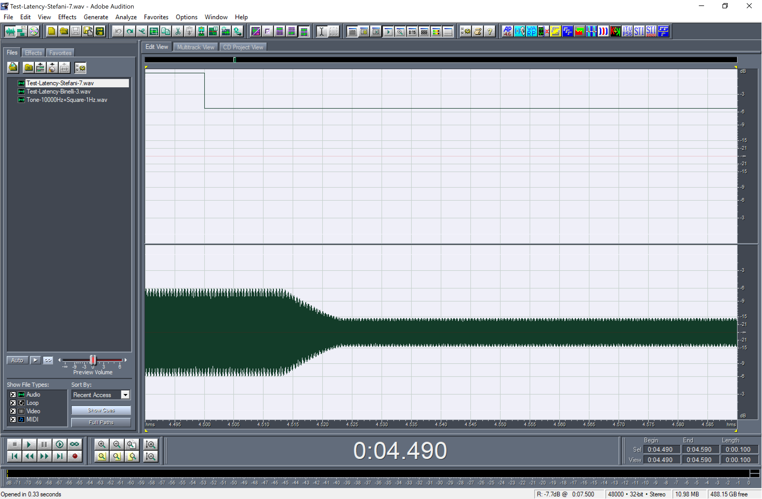
Latencies:
BINELLI: 42 ms
STEFANI: 13 ms
Cross-fade duration:
BINELLI: 10 ms
STEFANI: 10 ms

